Elefant 5 |  | Elefant 5
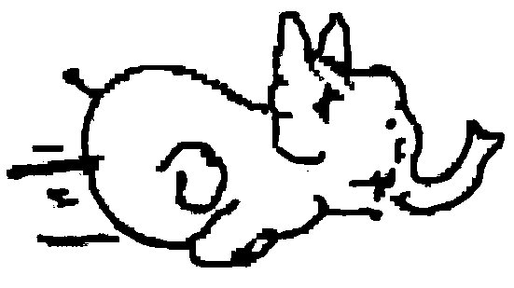
Elefant 5 |  | Zebra 4
 |  | 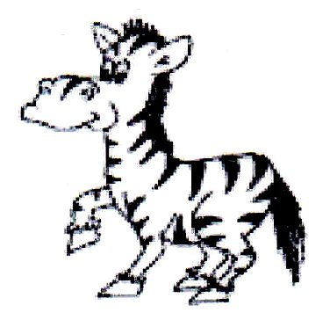
Elefant 5 |  | Zebra 4
Zebra 4 |  | Zebra 4
Zebra 4 |  | Zebra 4
Gazelle 3 |  | Gazelle 3
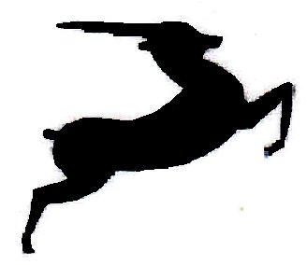
Gazelle 3 |  | Gazelle 3
Gazelle 3 |  | Gazelle 3
Gazelle 3 |  | Gazelle 3
Affe 2 |  | Affe 2

Affe 2 |  | Affe 2
Affe 2 |  | Affe 2
Affe 2 |  | Affe 2
Maus 1 |  | Maus 1
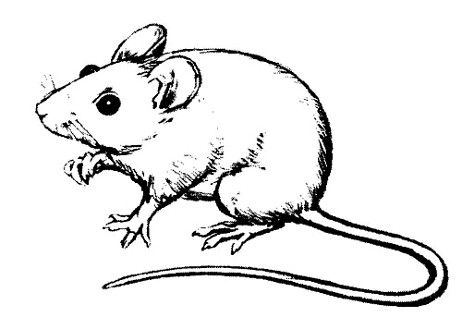
Maus 1 |  | Maus 1

